**MACHINE LEARNING -ICP#3**

Student Name: Datha Sai Bhaskar Sarma Vavilala

Student Id: 700756865

GitHub link: https: [https://github.com/dxv68650/ICP-3](https://github.com/dxv68650/ICP-3%20)

**QUESTION-1:**

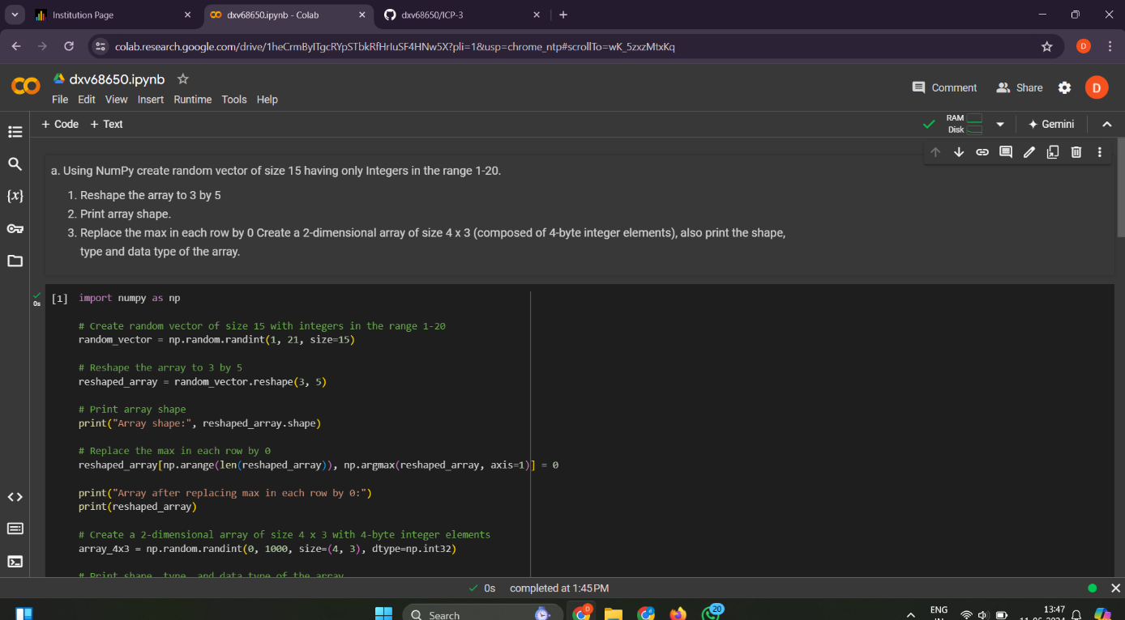 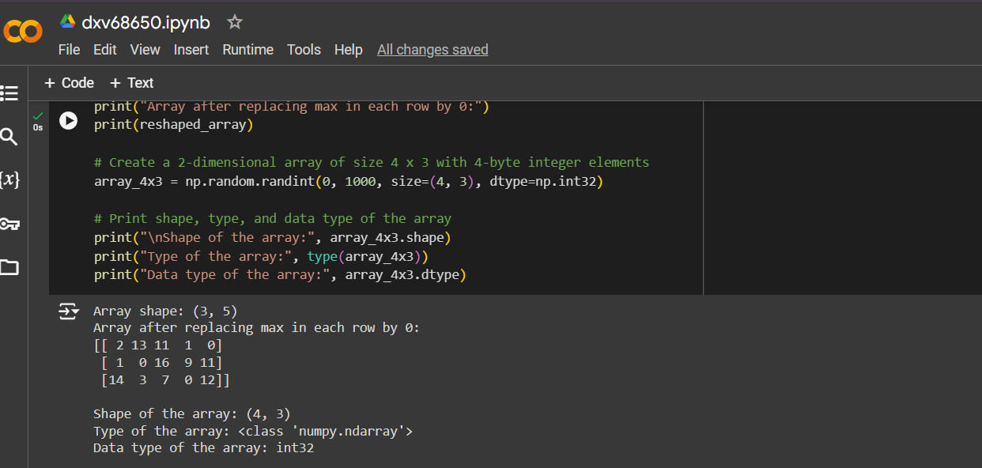

**QUESTION - 2:**

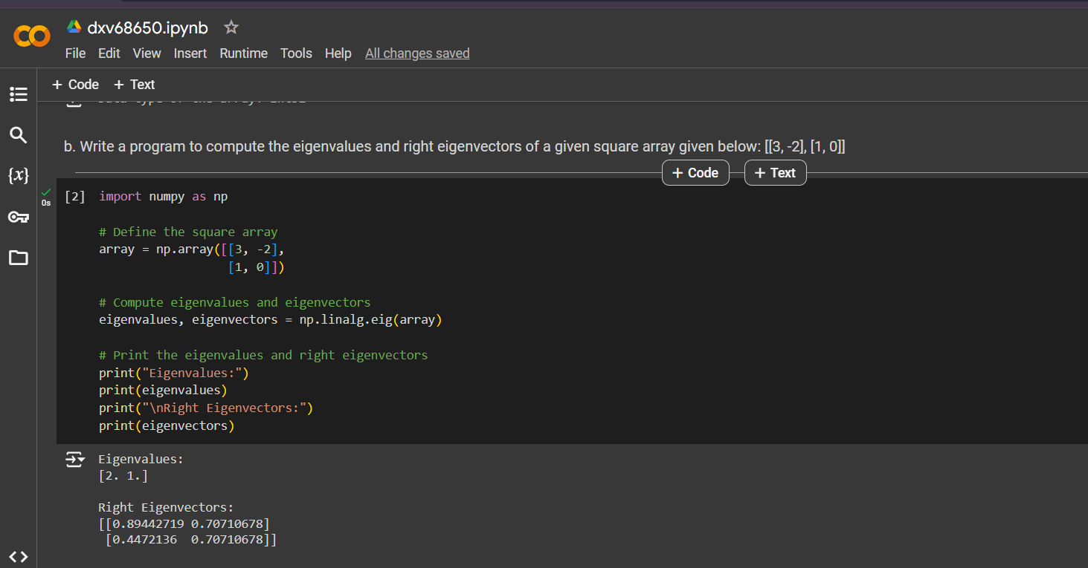

**QUESTION-3:**

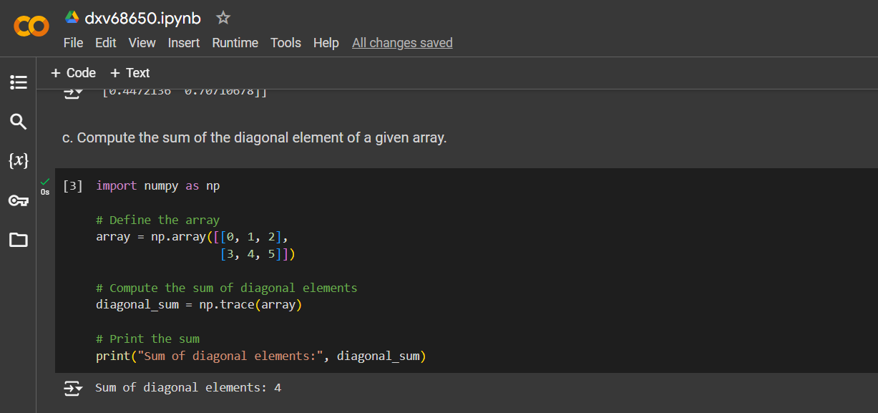

**QUESTION-4:**

